**Phase – II**

**Practice Project – I**

**Retrieving the Product Details Using the Product ID.**

**Sai Krishna Rajagopal**

**22-03-2022**

1. Screenshots:

Output:

Index:

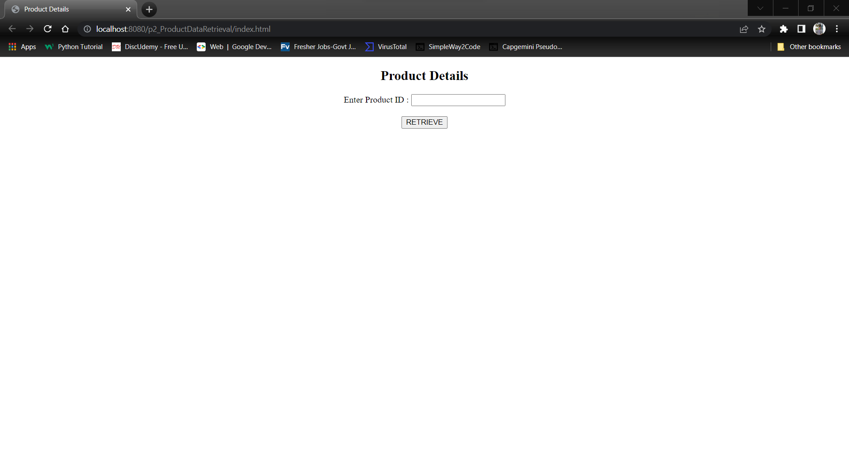

Output1:

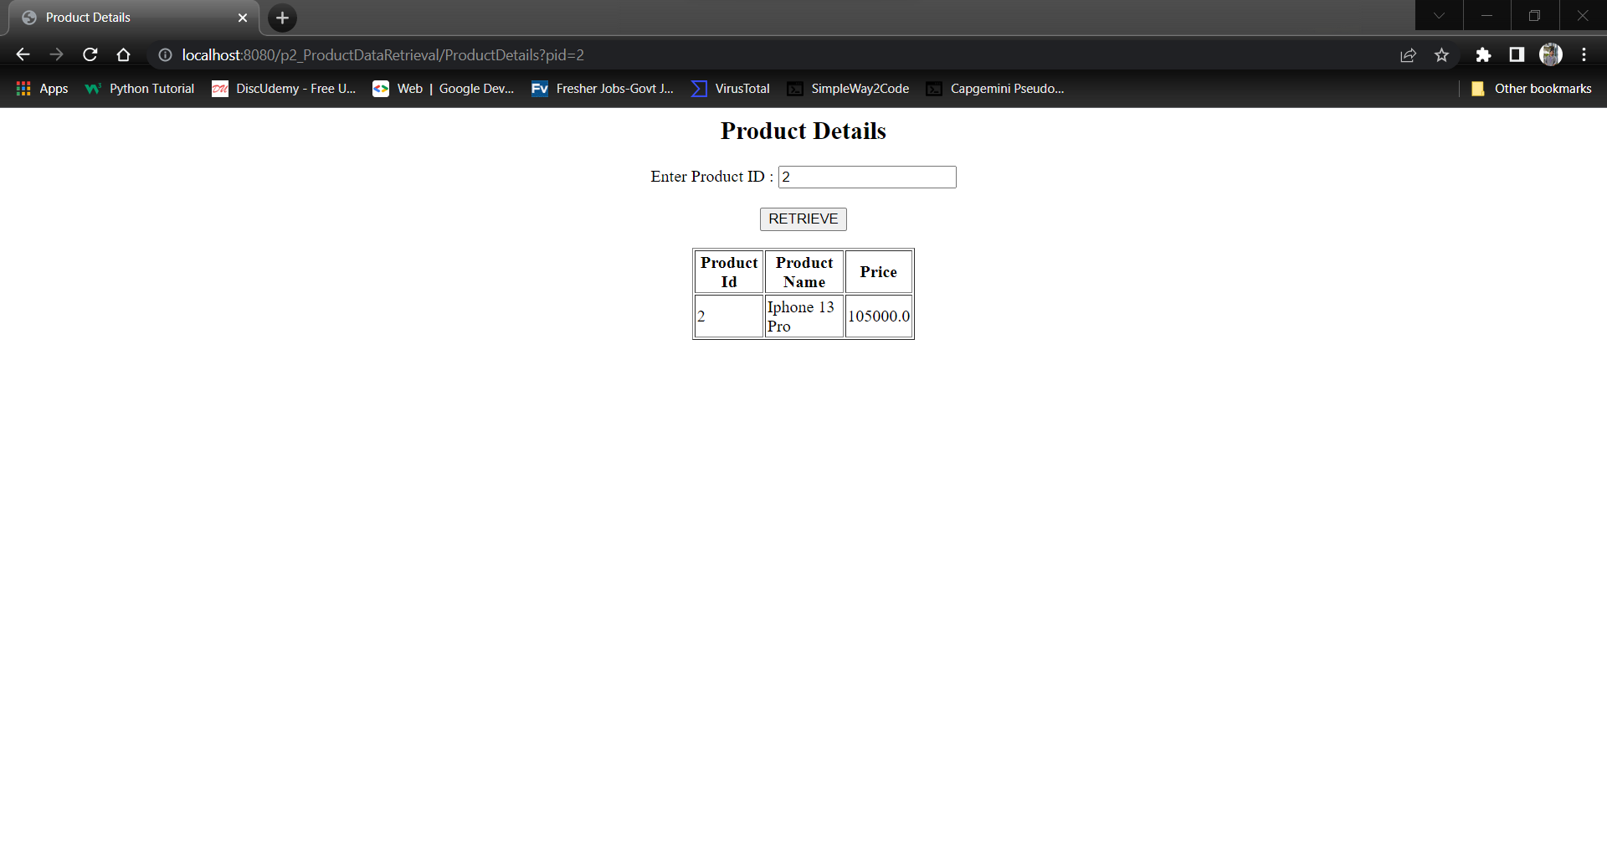

Output 2:

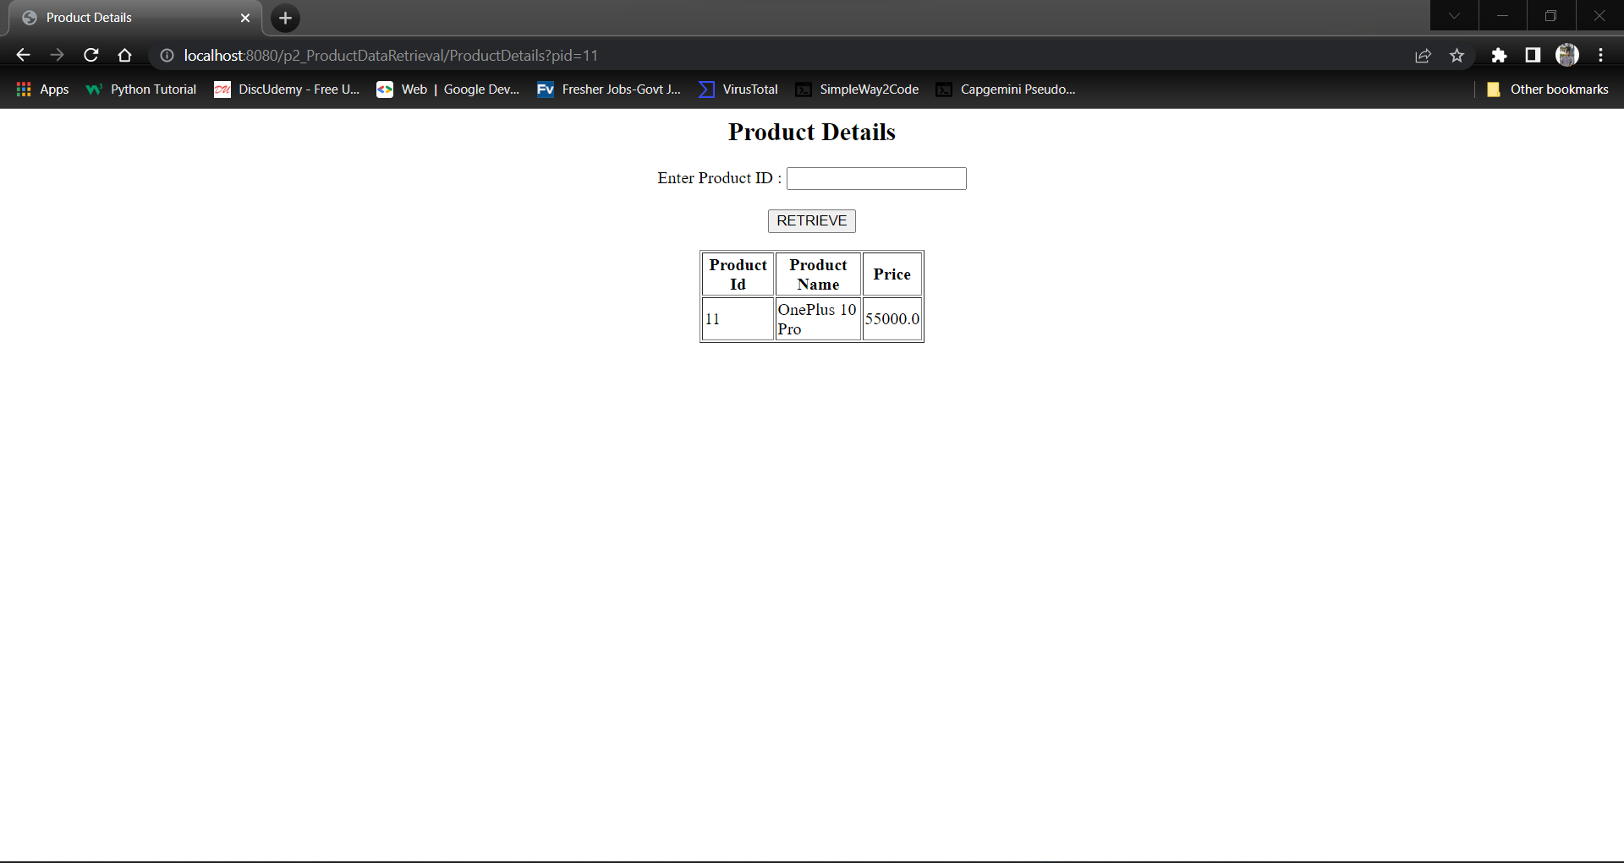

Git:

